Automated systems
IGCSE Computer Science 0478 | 6.1 | Student booklet
Name: _______________________________ | Date: _____________

This booklet has everything you need for the lesson in one place. Work through it in order:
- Learn sections show the key slides. Read them carefully - they explain the ideas and show worked examples.
- Task sections are where you practise. Each task uses what the slides just before it taught you.
- Tasks use real Cambridge IGCSE exam questions and get harder as you go. Task 5 is an extension.
Do Task 1 from memory before you turn the page.
Task 1 Recall test - sensors [8 marks]
Closed book. 5 minutes.
1 Identify the most suitable sensor for each use. [6]
Use | Sensor
Keep the temperature of a room constant
Detect a person standing within 1 metre of a machine
Measure the amount of rain collected in a rain gauge
Switch garden lights on when it gets dark
Check whether the soil in a greenhouse is too dry
Detect when a games controller is tilted

2 State what is meant by a microprocessor. [1]
0478/12 February/March 2026

3 An air-conditioning system uses a temperature sensor. Tick (✓) one box to show whether the sensor is an example of an input, output, process or storage device. [1]
0478/13 October/November 2025
 | Device | Tick (✓)
A | input
B | output
C | process
D | storage

Learn Automated systems and sensors
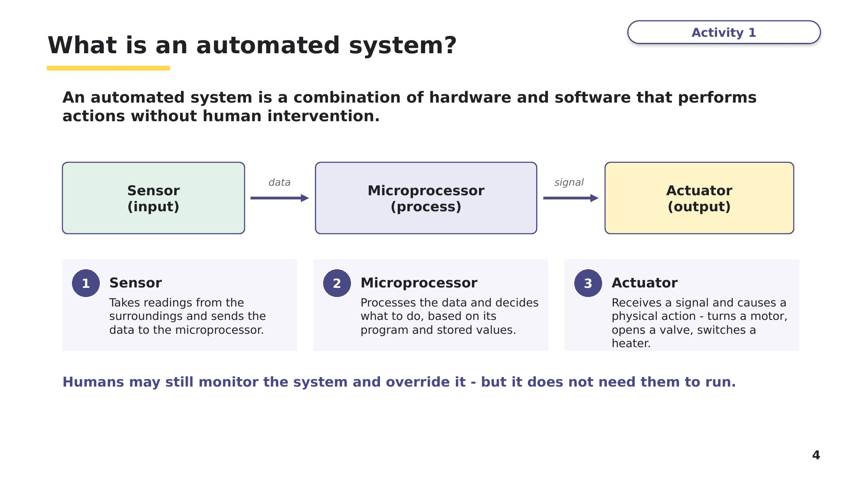
Slide 4 - What is an automated system?
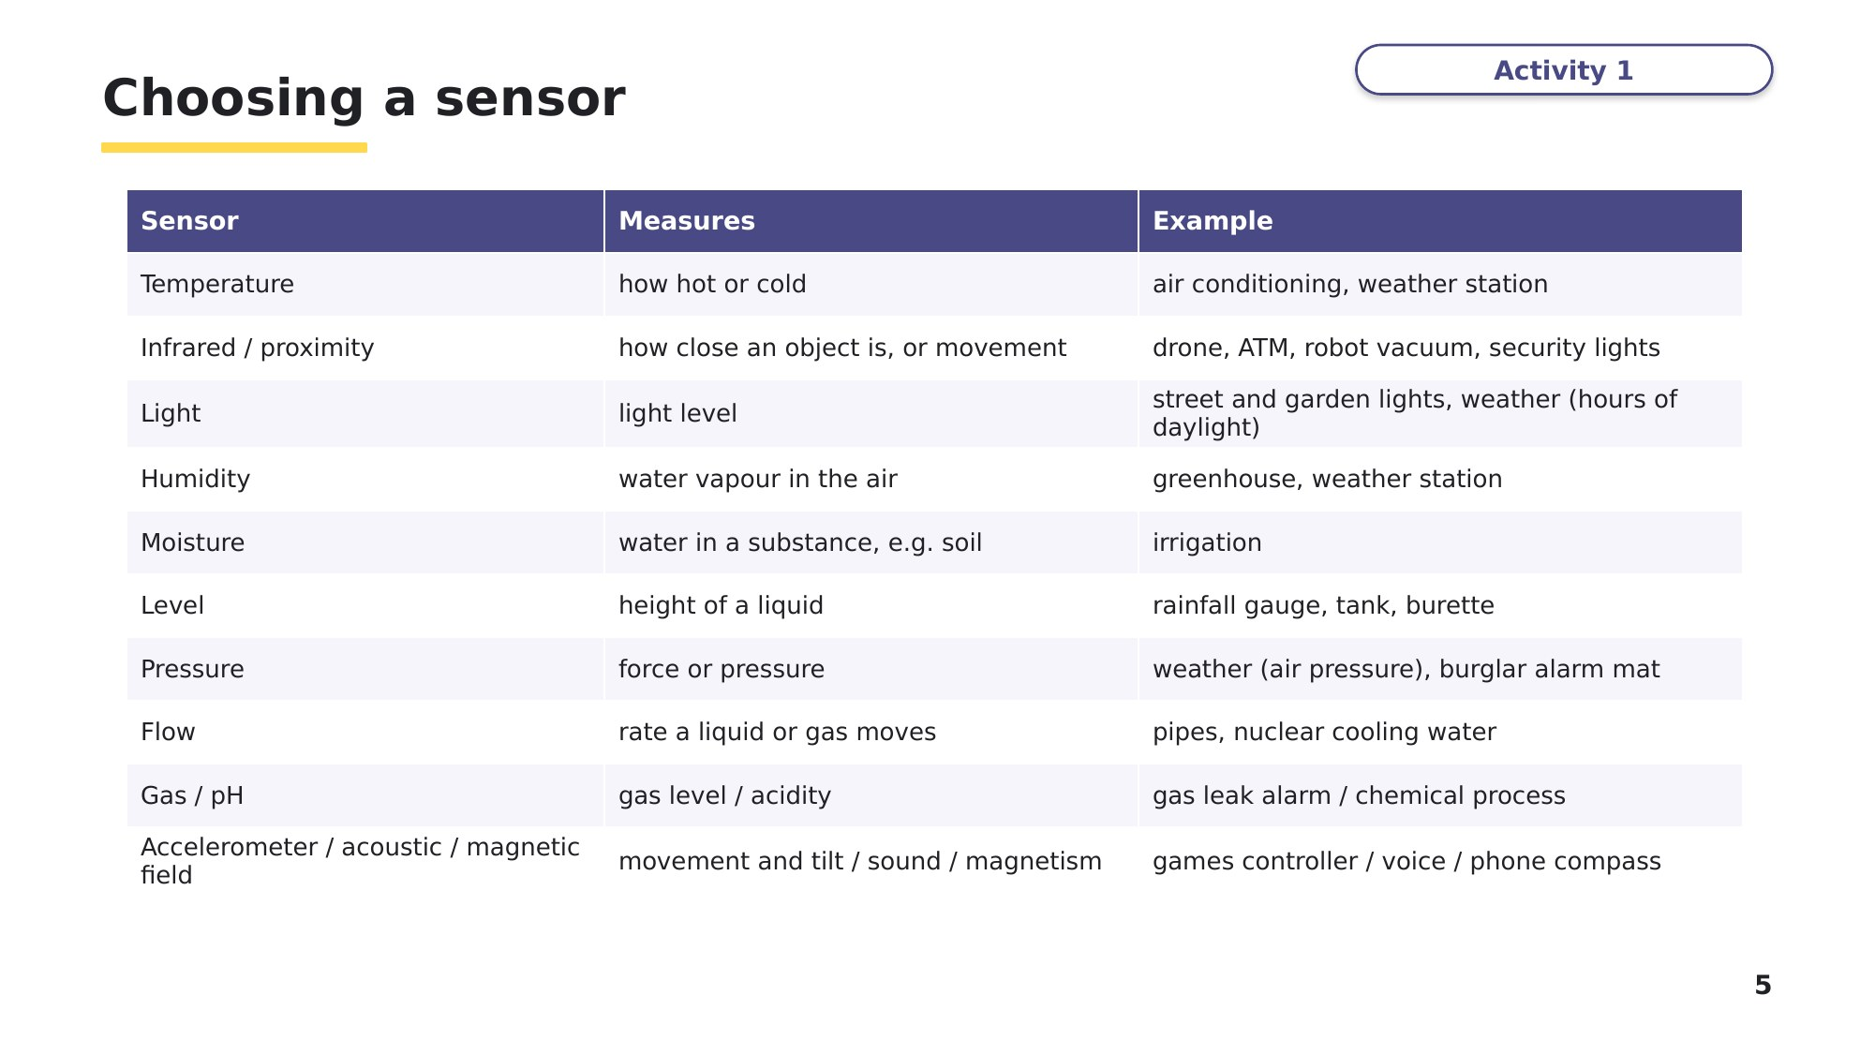
Slide 5 - Choosing a sensor
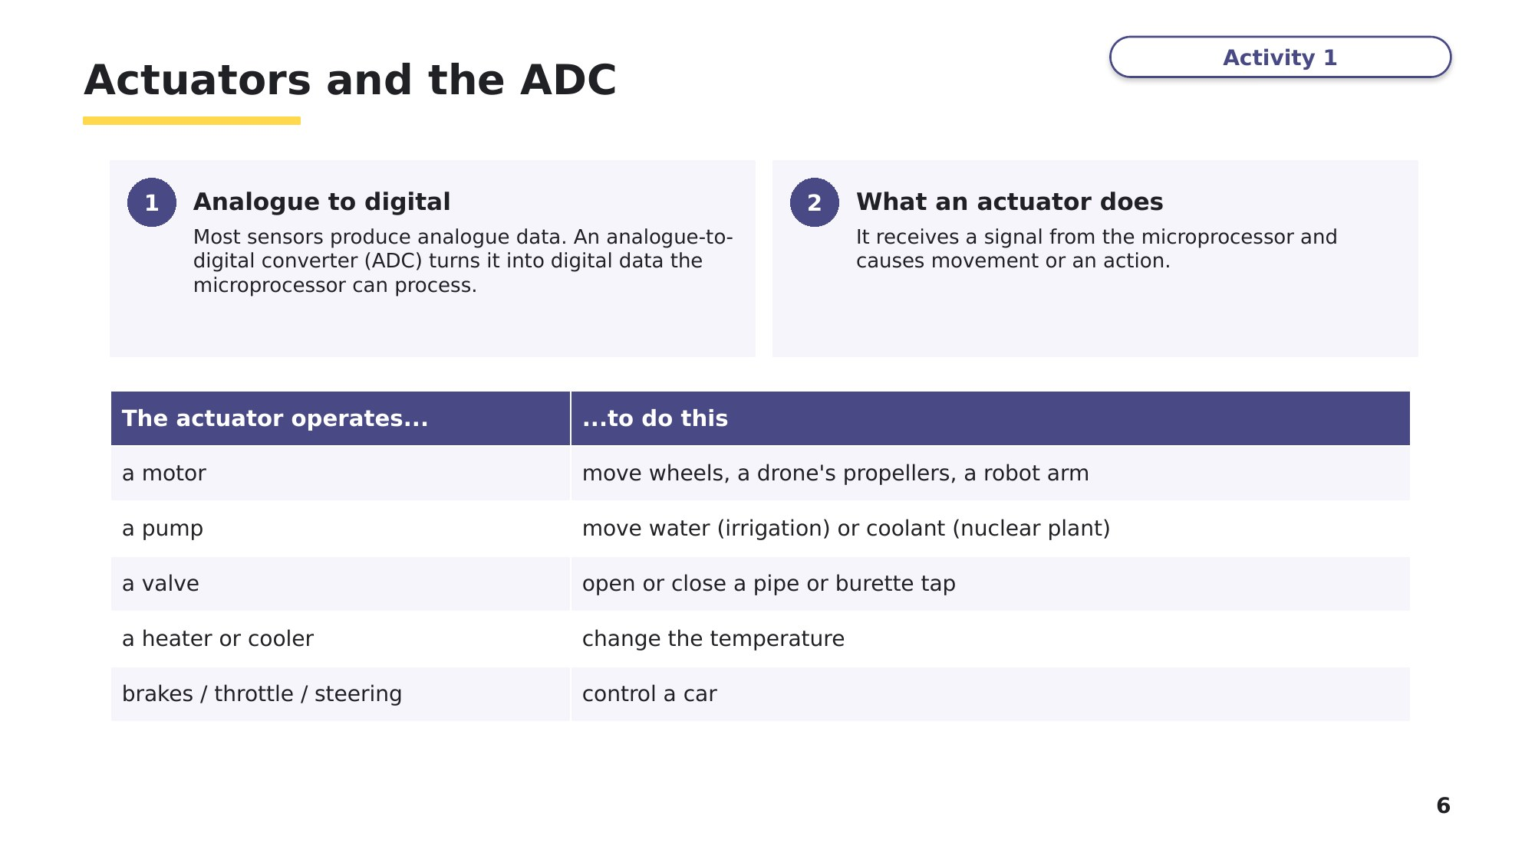
Slide 6 - Actuators and the ADC
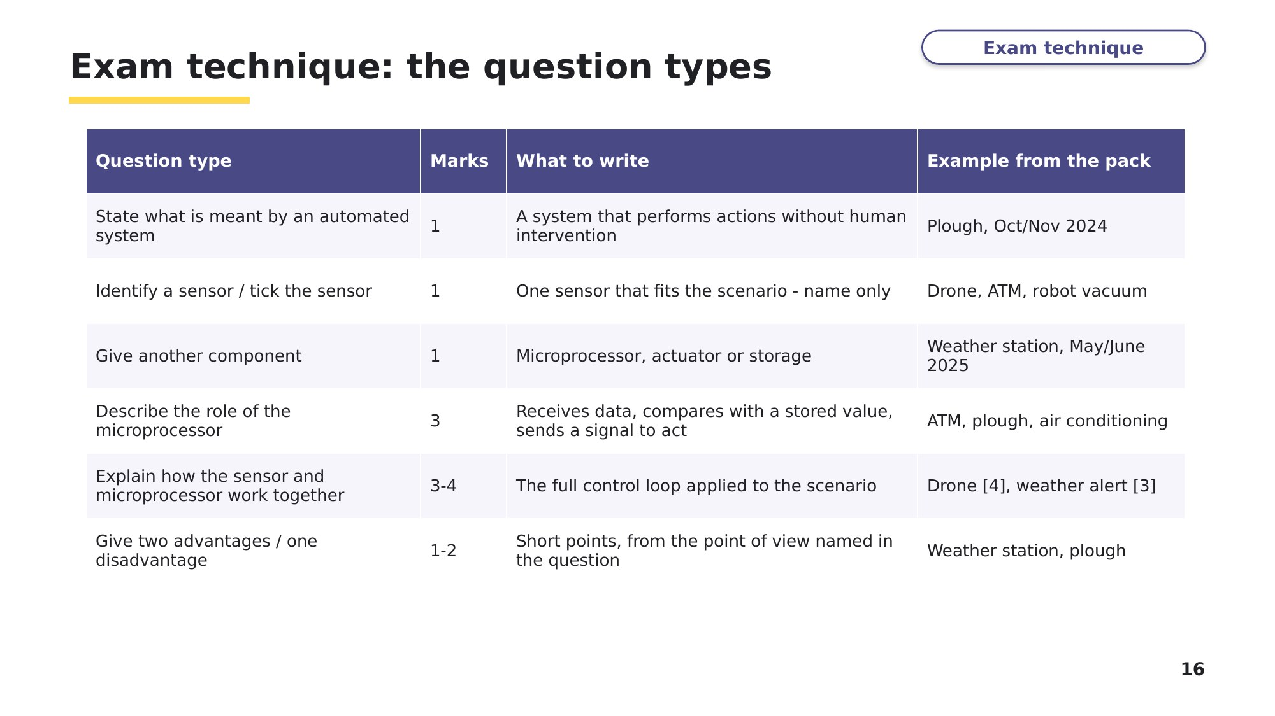
Slide 16 - Exam technique: the question types

Task 2 Definitions and choosing sensors [6 marks]
(a) A farmer has a plough that is an automated system. State what is meant by an automated system. [1]
0478/13 October/November 2024

(b) A drone has a built-in system to stop it from crashing into objects, for example a tree. The system uses sensors and a microprocessor. Identify one sensor that could be built into the drone to detect if it is near an object. [1]
0478/12 February/March 2026

(c) A robot vacuum cleaner uses sensors to navigate around obstacles in a room. Tick (✓) one box to show which sensor would be the most suitable for this purpose. [1]
0478/12 October/November 2024
 | Sensor | Tick (✓)
A | proximity
B | flow
C | pressure
D | level

(d) A sensor is used to detect when a person stands within 1 metre of an automated teller machine (ATM). Identify an appropriate sensor for the ATM to use to detect a person. [1]
0478/12 February/March 2025

A weather station uses automated systems to collect and analyse data about the weather. The automated system uses sensors.
(e) Give one other component that would be part of the automated system. [1]

(f) One sensor that is part of the automated system is a temperature sensor. Give one other sensor that could be part of the automated system. [1]
Parts (e) and (f): 0478/13 May/June 2025

Learn The control loop
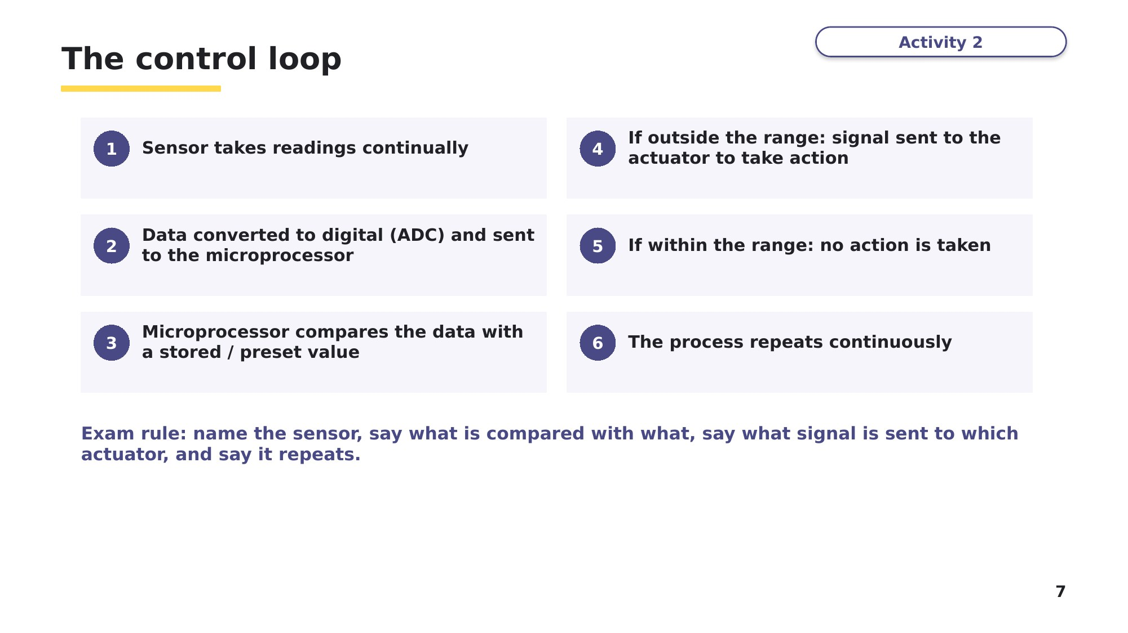
Slide 7 - The control loop
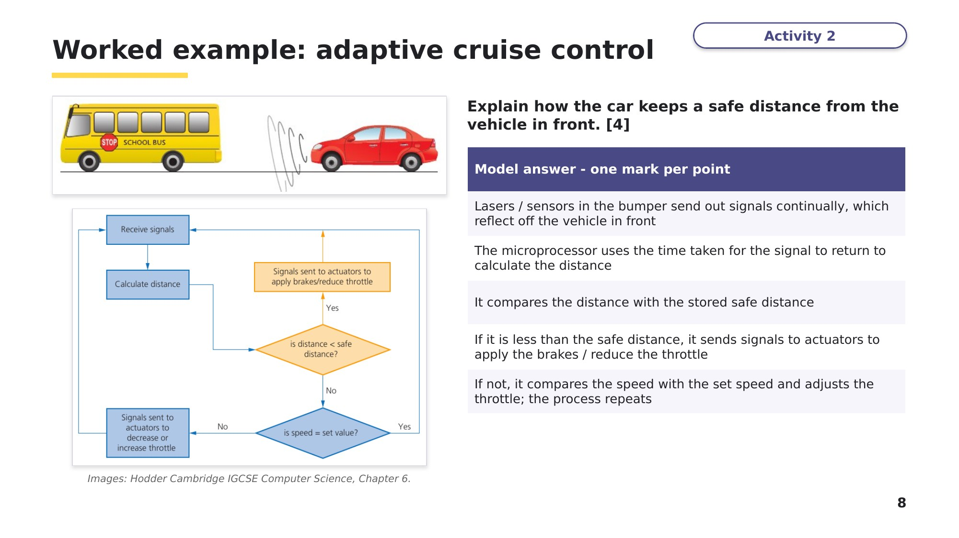
Slide 8 - Worked example: adaptive cruise control
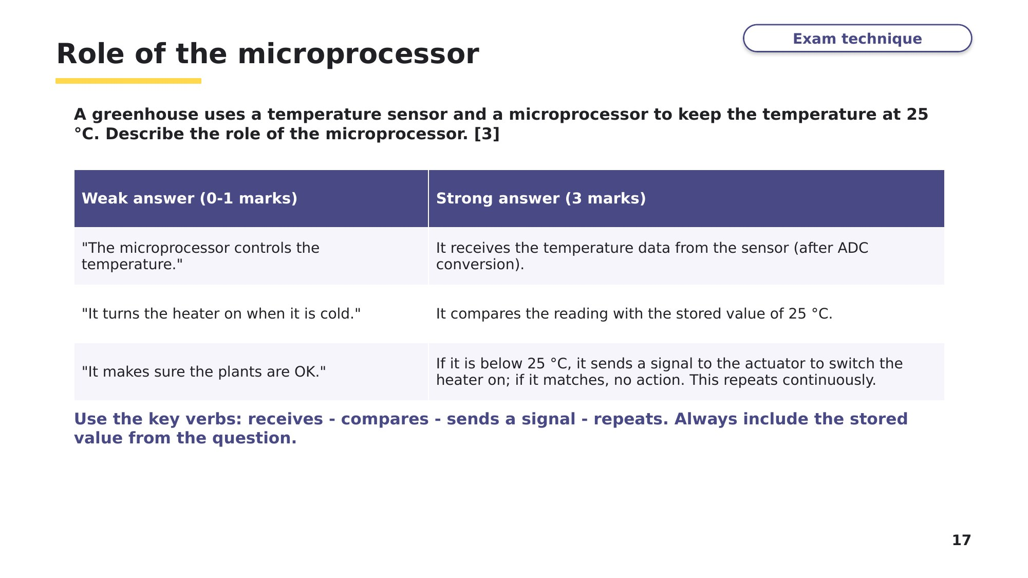
Slide 17 - Role of the microprocessor

Task 3 The control loop [16 marks]
Use the control loop: the sensor sends data - the microprocessor compares it with a stored value - it sends a signal to act (or takes no action) - it repeats.
(a) Explain how the sensor and microprocessor work together to stop the drone crashing into an object. [4]
0478/12 February/March 2026

(b) The air-conditioning system uses a temperature sensor and a microprocessor to keep the temperature of the room at a constant level. The temperature sensor continuously sends analogue data to the microprocessor. This data is then converted to digital. Explain how the microprocessor keeps the temperature of the room at a constant level. [3]
0478/13 October/November 2025

(c) When a person is detected within 1 metre of the ATM, a welcome message is displayed on the screen. Describe the role of the microprocessor in detecting the person. [3]
0478/12 February/March 2025

(d) An alert is sent to an employee in the weather office if a temperature above 40 °C is detected. Explain how a temperature above 40 °C is detected for the alert. [3]
0478/13 May/June 2025

(e) The plough uses sensors and a microprocessor to maintain a straight line when digging the ground. Describe the role of the microprocessor in this process. [3]
0478/13 October/November 2024

Learn Automated systems in action
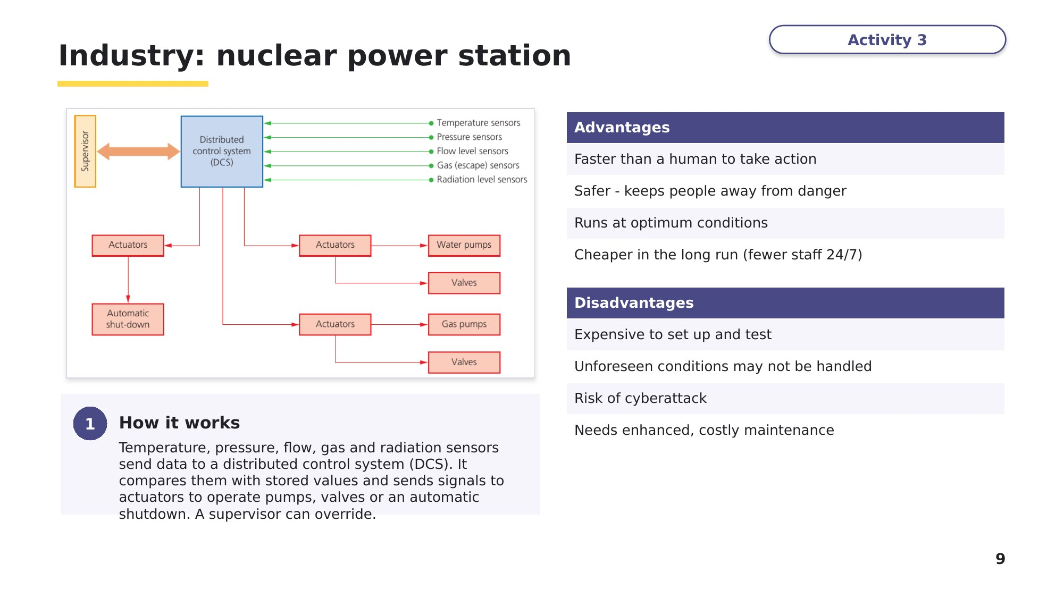
Slide 9 - Industry: nuclear power station
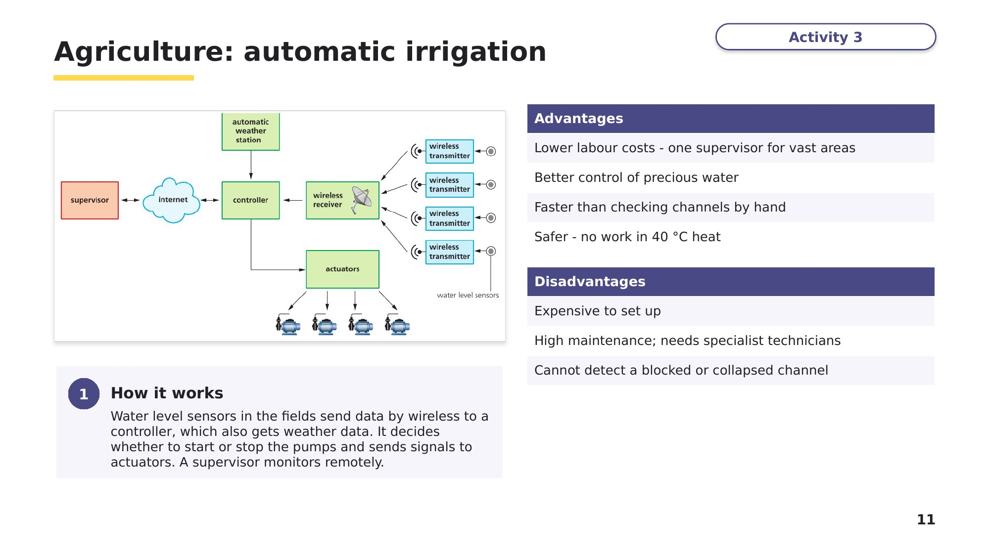
Slide 11 - Agriculture: automatic irrigation
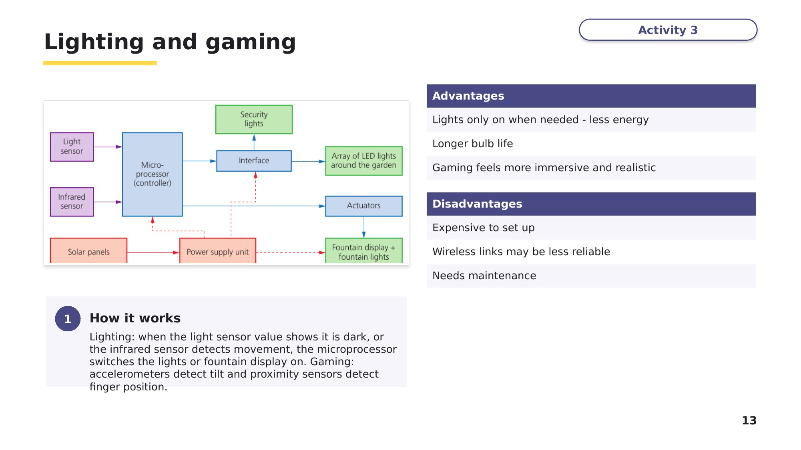
Slide 13 - Lighting and gaming
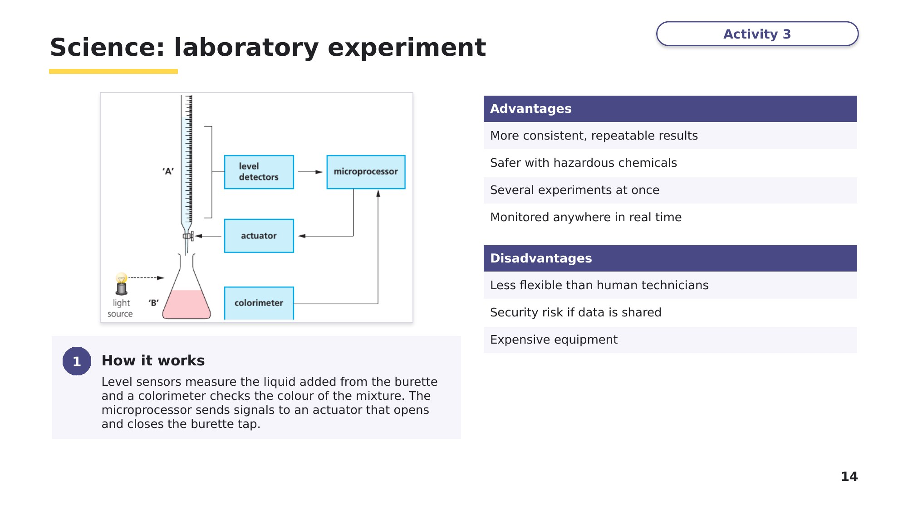
Slide 14 - Science: laboratory experiment
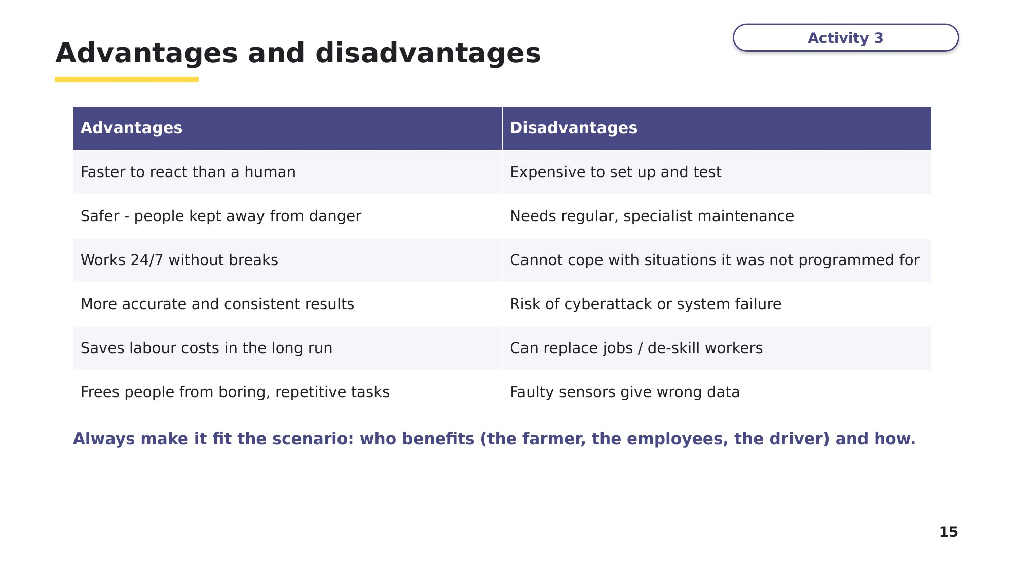
Slide 15 - Advantages and disadvantages
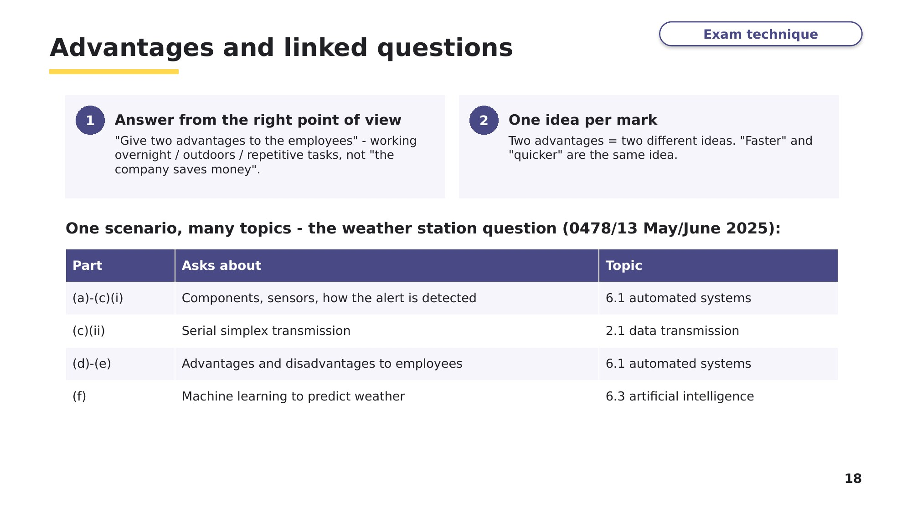
Slide 18 - Advantages and linked questions

Task 4 Advantages and disadvantages [9 marks]
(a) Give two advantages to the weather station employees of using an automated weather system. [2]

(b) Give one disadvantage to the weather station employees of using an automated weather system. [1]
Parts (a) and (b): 0478/13 May/June 2025

(c) Give two benefits to the farmer of using an automated system to plough the field. [2]
0478/13 October/November 2024

(d) A car has an automatic self-parking system. Give two advantages and two disadvantages of using this automated system. [4]
Exam-style question written for this lesson.
Advantages | Disadvantages

Learn Check your Task 4 answers
Only look at these slides once you have finished Task 4.
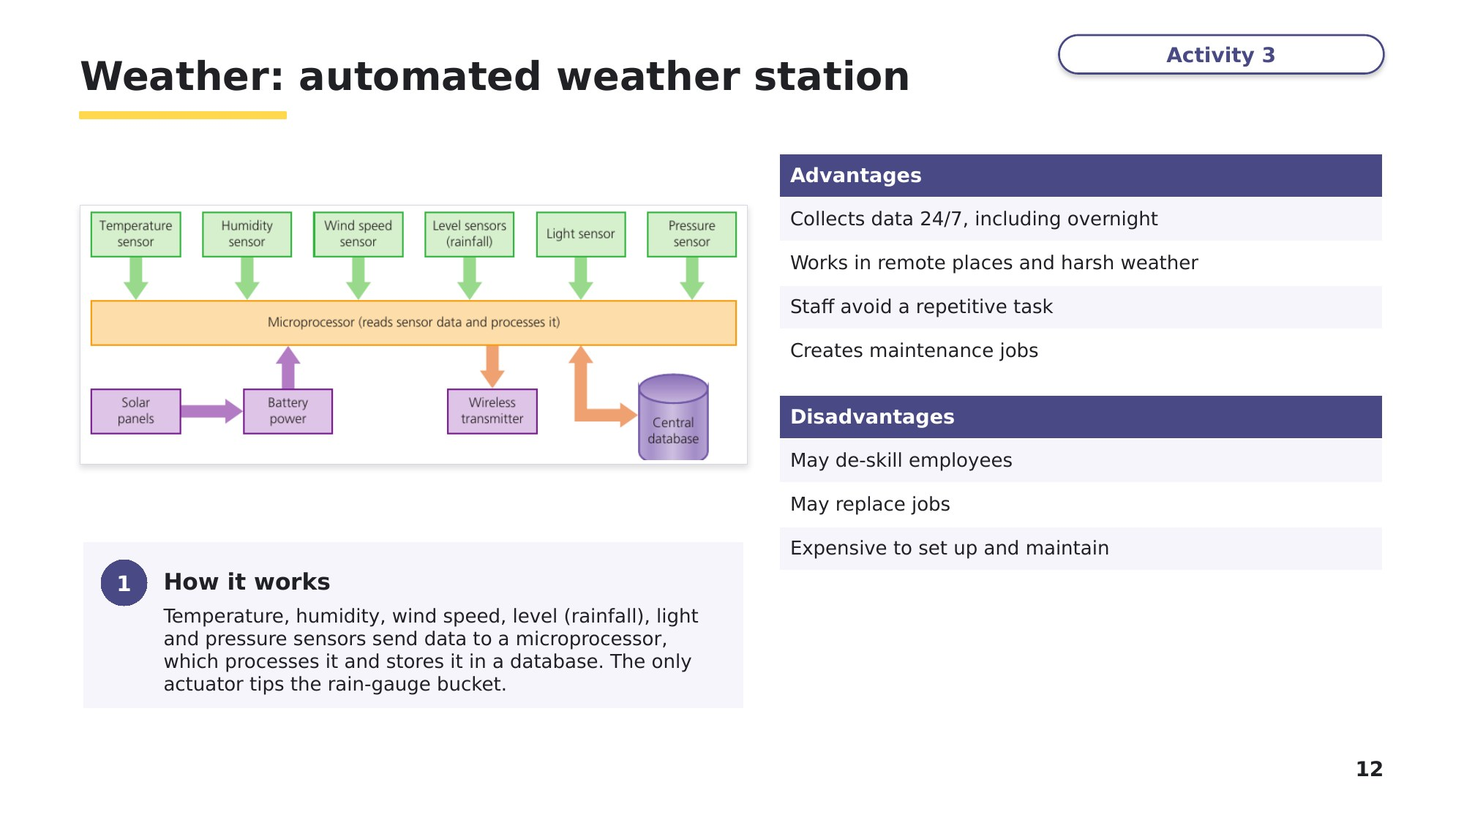
Slide 12 - Weather: automated weather station
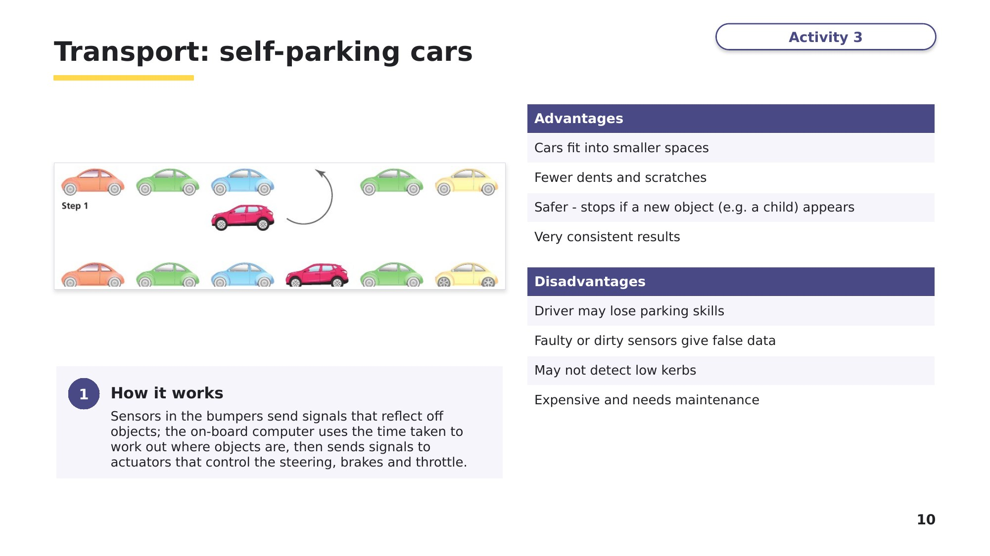
Slide 10 - Transport: self-parking cars
Task 5 Extension - linked questions [10 marks]
Scenario questions often continue into embedded systems (topic 3.1).
(a) The air-conditioning system is an example of an embedded system. Explain why the air-conditioning system is an embedded system. [2]
0478/13 October/November 2025

(b) Describe the features of the ATM that identify it as an embedded system. [2]
0478/12 February/March 2025

(c) A large greenhouse is used to grow tomatoes. For the best growth, the tomatoes need the right light level, the correct temperature and regular watering. Describe how an automated system could keep the correct growing conditions. The only human involvement is a remote supervisor. [6]
Based on textbook Activity 6.5, question 2.

Learn Review
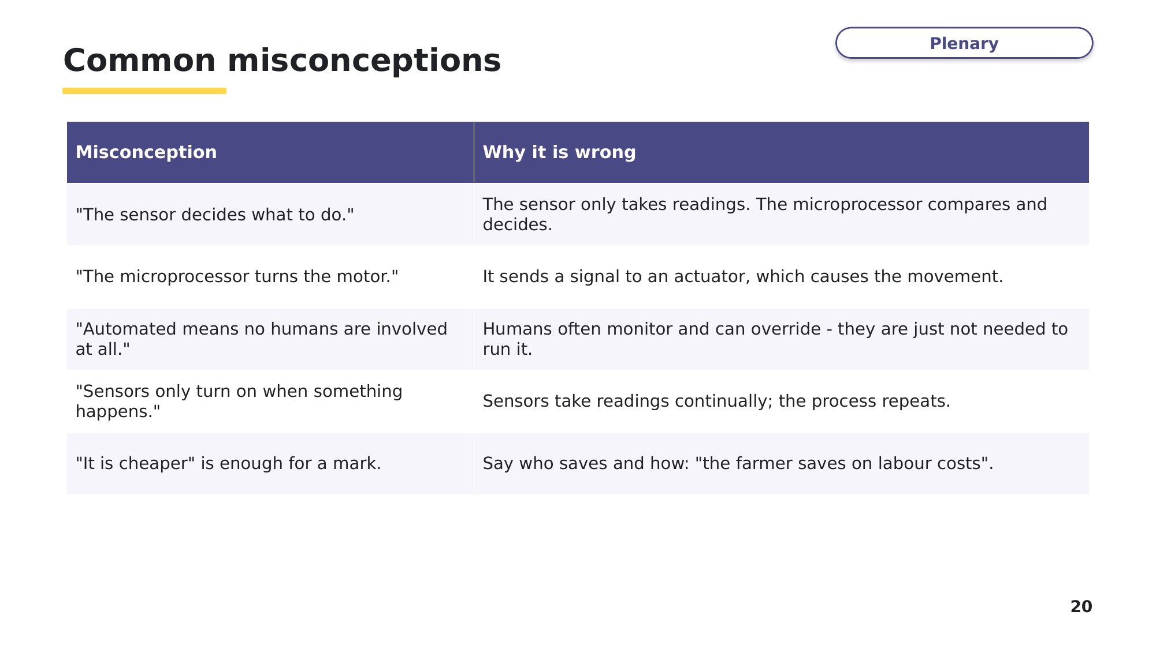
Slide 20 - Common misconceptions
Exit question
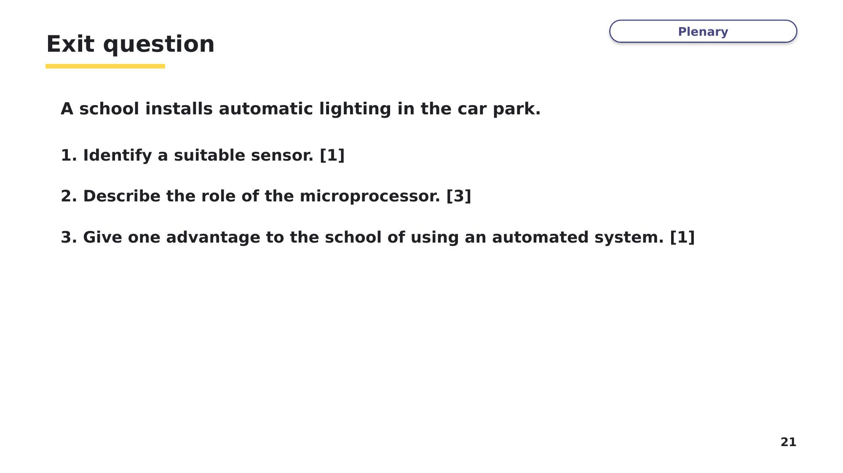
Slide 21 - Exit question

